Exercise 1







Painting





Illustration

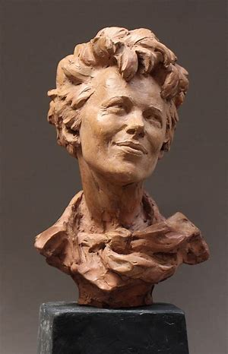



Sculpture





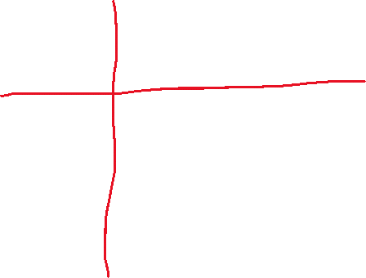

Photograph

Exercise 2

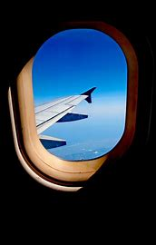 This photograph uses the commonsense principle; less is more with the simple part. With this photograph you can see the main part of the photo is the airplane wing.

 This painting uses the commonsense principle; draw what you want to see. The artist probably saw this outside and when they thought of this idea, they wanted it to look more like this.

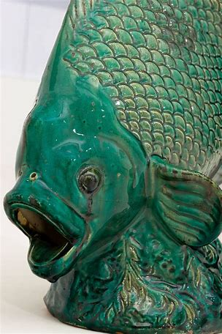This sculpture uses the commonsense principle; no one part of the composition is as important as the whole. The scales on the fish are not more important than the fins. With the whole composition you can tell it is a fish, if it was separated it wouldn’t be representational.

This illustration uses the commonsense principle; create a negative space, then fill it. The artist kept the white as the negative space then filled in a face to make the white look like hands.

Exercise 3

Composition 1

Composition 2

Composition 3

